Experiment 4: Counter Design using Vivado IP
Objectives
  - To configure an 8-bit Binary Counter IP core in Xilinx Vivado with an increment value of 2.
  - To create and configure a 16-bit Binary Counter IP core in down-counter mode with a decrement value of 1.
  - To construct top-level modules and HDL wrappers connecting system clock, reset, enable, and counter output buses.
  - To carry out behavioral simulation in Vivado Simulator (XSIM) to verify counter progression, down-counting sequence, and rollover behavior.

Software Required:
Xilinx Vivado Design Suite, Vivado IP Catalog, Vivado Simulator (XSIM).
Procedure
A. Design of 8-Bit Up-Counter Circuit (Increment of 2)
1. Open Xilinx Vivado and create a new project targeting the appropriate FPGA device.
2. Open Vivado's IP Catalog and add a Binary Counter IP core (`c_counter_binary`). Set output width to 8 bits and set increment value to 2 (connecting constant 2 to increment input).
3. Create a top-level module connecting clock (`CLK`), reset, and 8-bit output (`Q` / `out1`).
4. Write a Verilog testbench (`tb_clock_divider_by4`) to provide a periodic clock signal, apply reset initially, and monitor output count.
5. Launch Vivado Simulator (XSIM) and inspect the output waveform to confirm that the counter increments by 2 on each rising clock edge (sequence: 0, 2, 4, 6, ..., 254, 0 rollover).
B. Design of 16-Bit Down-Counter Circuit (Decrement of 1)
1. Open Vivado and create a new RTL project. Enter project name and select target FPGA device.
2. Open IP Catalog, search for Binary Counter, customize output width to 16 bits, select down-counter mode, and enable clock and reset options. Generate the IP core.
3. Create an HDL wrapper for the generated IP and connect clock, reset, enable, and 16-bit output signals.
4. Write a Verilog testbench generating a periodic clock, applying initial reset, asserting enable, and initializing output to a known value such as FFFFH.
5. Execute behavioral simulation in Vivado Simulator (XSIM) and inspect waveform output to confirm that the count decreases by 1 on every clock pulse.
Program
1. Verilog Testbench Code for 8-Bit Up-Counter
`timescale 1ns / 1ps
module tb_clock_divider_by4;
reg clk;
reg rst;
wire [7:0] out1;
// Instantiate 8-bit Binary Counter IP core (Increment by 2)
c_counter_binary_0 uut (
.CLK(clk),
.Q(out1)
);
// Clock generation (100 MHz clock)
always #5 clk = ~clk;
initial begin
clk = 0;
rst = 1;
#20 rst = 0;
#100000;
$stop;
end
endmodule
2. Verilog Testbench Code for 16-Bit Down-Counter
`timescale 1ns / 1ps
module tb_16bit_down_counter;
reg clk;
reg rst;
reg enable;
wire [15:0] count_out;
// Instantiate 16-bit Down Counter IP core
c_counter_binary_1 uut_down (
.CLK(clk),
.SCLR(rst),
.CE(enable),
.Q(count_out)
);
always #5 clk = ~clk;
initial begin
clk = 0;
rst = 1;
enable = 0;
#20 rst = 0;
#10 enable = 1;
#1000;
$stop;
end
endmodule
Formulas
1. Up-Counter Modulo & Rollover Calculation:
Max Count = 2^WIDTH - 1 = 2^8 - 1 = 255
For Increment = 2: Maximum even state = 254. Next state: (254 + 2) mod 256 = 0 (Rollover).
2. Down-Counter Modulo & Underflow Calculation:
Initial State = 2^16 - 1 = 65535 (FFFFH).
For Decrement = 1: Sequence follows FFFFH, FFFEH, FFFDH, ..., 0000H, FFFFH.

Output
S.No | Output Parameter | Target / Expected Behavior | Simulated / Measured Result | Status
1 | 8-Bit Up-Counter Step | Increment by +2 | Increment by +2 | Verified
2 | 16-Bit Down-Counter Step | Decrement by -1 | Decrement by -1 | Verified
3 | Up-Count Sequence & Rollover | 0, 2, 4, ..., 254 -> 0 | 0, 2, 4, ..., 254 -> 0 | Verified
4 | Down-Count Sequence | FFFFH, FFFEH, FFFDH, ... | FFFFH, FFFEH, FFFDH, ... | Verified
5 | Operation Stability | Stable Count Transitions | Validated in XSIM Waveform | Pass

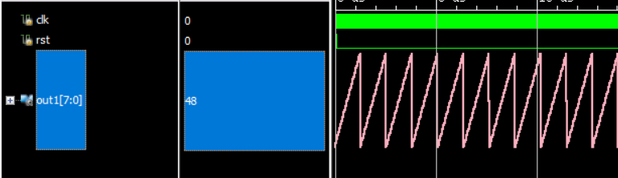
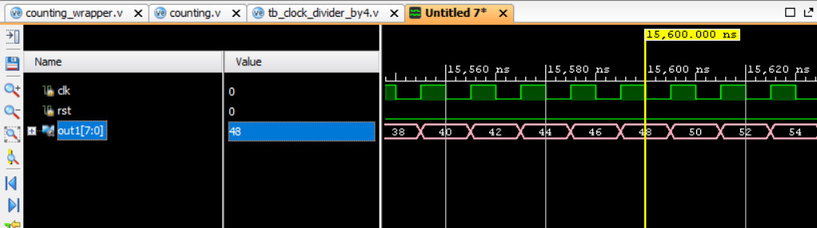
Figure: Upcounting by 2
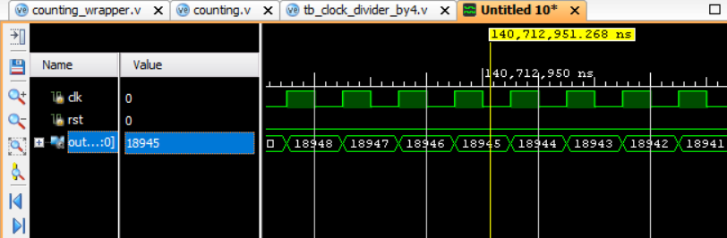
Figure: Example of downcounting by 2
Result
The 8-bit up-counter with an increment value of 2 and the 16-bit down-counter with a decrement value of 1 were successfully designed, configured, and simulated with the Vivado Binary Counter IP core. Simulation waveforms confirmed that the 8-bit up-counter increments by 2 on every rising clock edge (0, 2, 4, ..., 254) and rolls over accurately to 0. Similarly, the 16-bit down-counter decrements continuously by 1 on each active clock pulse from FFFFH downwards, confirming correct, stable hardware operation.

